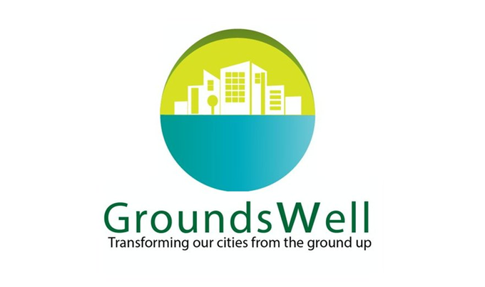
Data Linkage Consent
Hannah Burnett
Version 7

GroundsWell - Data linkage consent
Consent form:
Please read the form below, and the information leaflet, to learn what we (at the [University of Liverpool]) would like to do next with the survey results. In order to understand better how urban green and blue spaces can help improve people’s health and wellbeing, we would like to link some data, including health records held by the NHS (National Health Service), to the answers you have given in this survey. If you agree:
- We will securely transfer the survey contents (including your name, address, sex and date of birth) to a part of the NHS which is able to uniquely join it with a copy of your medical record. This part of the NHS is called the Data Services for Commissioners Regional Office (DSCRO).
- This joint survey-medical record copy will be held separately to your live medical record, meaning that your General Practitioner (GP) or any other medical professional will not be able to see your survey response.
- The DSCRO will extract relevant anonymous parts of this joint survey-medical record copy for academic and policy research purposes only.
- Access to the data will be restricted and controlled, to make sure that researchers use the information responsibly and safely. No participant will be able to be idenfitied or re-idenfitied by a researcher.
- This will not affect the services offered to you or your care given by the NHS or your Local Authority.
Please read the data linkage information leaflet for any further information you would like to know, including how to withdraw your consent in future.
Consent
I give my consent for the [University of Liverpool] to pass my name, address, sex, and date of birth to the DSCRO to link my NHS records with my survey responses and then make them anonymous, to be used for academic and policy purposes only.
Signature:

Print Name:

Date:

Information leaflet:
- Why are we asking for your consent to data linkage?
We would like to use data linkage to find out more about how people’s health, education and social context, for example, are related to use of green and blue spaces, without having to bother you with too many personal questions.
Ultimately, our research will help policymakers and public authorities to improve the environment in ways that support good health for people like you.
- Which records would we like to add?
The National Health Service (NHS) routinely updates medical and health-related records for all patients accessing NHS health services throughout their lives. This information is centrally managed by the NHS. Other procedures provided through private health care are not included.
- What do these records include?
Health records include:
- Use of NHS health services, such as visits to the doctor or nurse, hospital attendances and admissions
- Health diagnoses or conditions
- Medicines, surgical procedures, or other treatments received
- NHS number for England, Community Health Index (CHI) number for Scotland, Health and Care (H&C) number for Northern Ireland
Sharing information from these records will not affect your treatment as a patient.
- How does data linkage work?
- University researchers will securely transfer your personal identifiers (name, address, sex, and date of birth) to the government departments/agencies that hold your health records.
- Once your records have been identified and linked to the survey data, your personal identifiers will be removed from the dataset.
- Only the linked, anonymised data are seen by the researchers. Your personal identifiers are never included in linked data, so researchers analysing the data will never see them.

- Who will have access to this data?
Only a select number of researchers working within the University of Liverpool will have access to these data. All data is anonymised, therefore none of the researchers will see any of your personal details. No individual can be identified from the research.
The data can only be accessed in a secure research environment, and only researchers trained by the ONS (Office for National Statistics) in Safe Researcher Training will be able to access the anonymised data.
- What if you change your mind?
You can withdraw your consent to data linkage by contacting the [University of Liverpool] using the details below. We will remove data about you, including data that is personally identifiable (e.g., information such as your name, address), but we will not remove data from datasets that have been anonymised and linked.
- Further information
- We will not pass any of your data onto third party organisations.
- If you would like to receive notifications of our work via email, or to find out more about what is being done with your data, please contact [___].
- Contact us for further information: Call us on [phone number], email us at [email], or write to us at [address].

Version history
Date/Version No | Key Amendments Implemented | Amendment Author/Organisation | Amended by
10-11-22 | First draft | Hannah Burnett | HB
16-12-22 | Added bullet point list to consent form | WP4 GroundsWell Colleagues | HB
30-03-23 | The first sentence “We would like to add records held by the NHS (National Health Service) to the answers you have given in this survey” was changed to better reflect what we actually want to do | Data Governance Committee | HB
21-06-23 | Changes to wording in consent form to make more simple | ARC (Appled Research Collaboration) CHI (Care and Health Informatics) Team | HB
26-06-23 | Update/elaborate on bullet point methodology | Dr Olly Butters (WP4) | HB
20-07-23 | Consider separating consent form and information booklet, small changes to wording | Prof Catharine Ward Thompson (WP3) | HB
15-08-23 | Minor changes (e.g., add “Add, if correct, that no participant will be able to be identified or re-identified by a researcher”, update to include signature and name) | NHS Data Asset Group | HB
Also assessed by contacts in eDRIS (electronic Data Research and Innovation Service) in April 2023 – no amendments to be made.

